

ACLAS manager
User’s guide
Curaçao

INDEX
1. INSTALLATION 2
2. LOG IN 2
3. OVERVIEW OF APPLICATION 3
4. MODULES 3
MACHINES MENU 4
PARAMETERS MENU 5
Reading the device′s parameters 5
Parameters Configuration 6
DEPARTMENTS MENU 6
Reading the Department Parameters 6
Entering a new Department to the device 7
Editing a department 7
Deleting a department 7
Sending departments 8
PLUs 8
Configuring the PLU 8
Creation of a new PLU 9
Editing a PLU 9
Deleting a PLU 9
Sending PLU 10
KEYBOARD 10
LOGO 11

INSTALLATION

Execute the application installer (AclasManagerHKAInstaller.msi). Once the installation process is over, locate the Aclas Manager HKA icon on your desktop and execute the application.

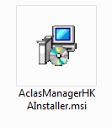 | 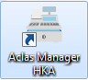  Application Icon

LOG IN

Type your login and password, and then click on “Log in”. If you are running the application for the first time enter the administrator’s account default credentials (Name: admin and Password: admin) and click on “Log in”:

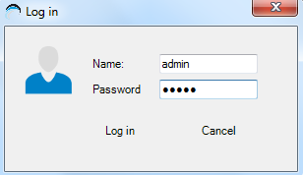
Entering the user’s credentials

OVERVIEW OF APPLICATION
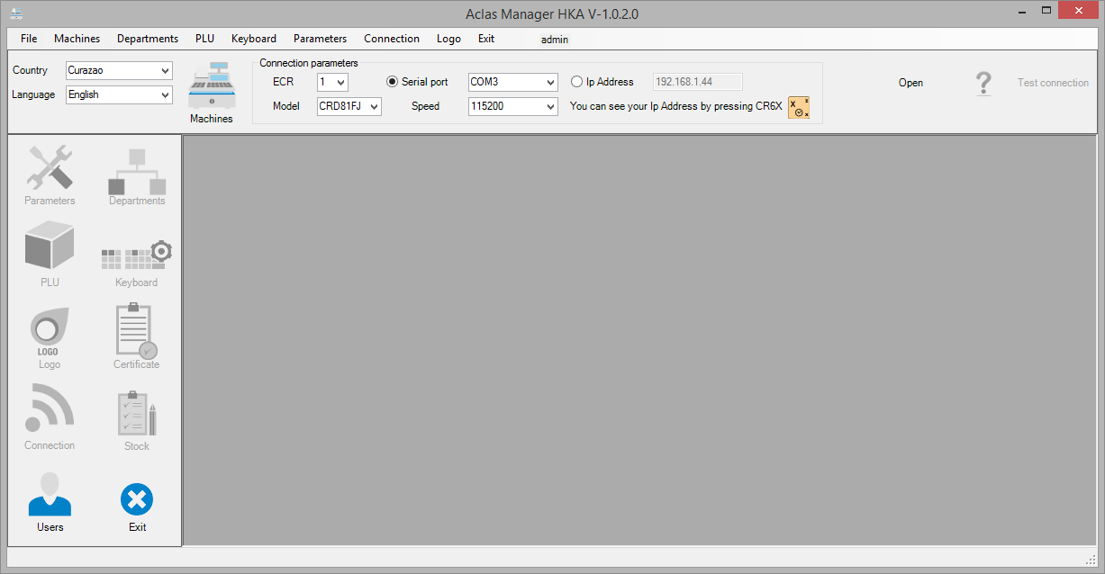
Once you have entered your login credentials properly, you'll be granted access to the application. The Parameters, Departments, PLUs, Keyboard and Logo modules (located to the left) will remain disabled until a connection with a cash register has been established.
The application works with Curaçao, Venezuela, México and Dominican Republic devices. The program's interface is in English by default. If you want to change this setting, select the country and the desired language.

To establish a connection with your cash register, it’s required you indicate the Connection Parameters as follows:
- ECR: you could create a profile to every Cash Register you connect to the Aclas Manager, and each profile identification number must be written here.
- Model: Select the cash register model, in this case is CRD81FJ.
- Connection type: Indicate the corresponding Serial Port
- Speed: Select the connection speed. For the CRD81FJ model this is 115200

Click on “Open” to establish communication with your cash register. The application will make a communication test. If this test is successful the following message appears:
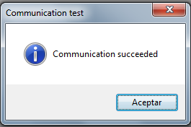
Successful communication test

MODULES
Each module is accessible via the control panel or by the corresponding icon. It is recommended to open each module the order presented in this document.
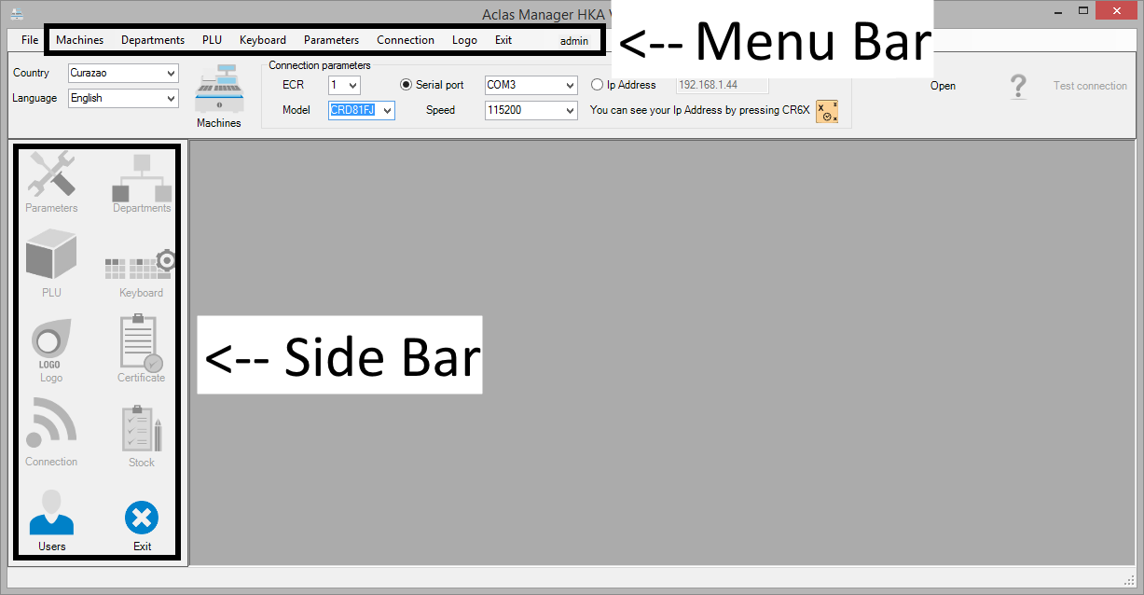

MACHINES MENU
This menu is represented whit the following icon:
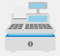
Inside this section you will be able to manage the parameters of the your(s) Cash Register(s). Such as ECR’s name, ECR’s model, communications speed, maximum number of departments and maximum number of PLU

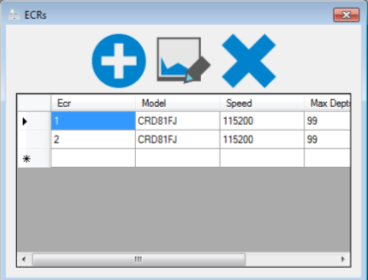

To add a new device, click on the  symbol, and proceed to edit the corresponding parameters.

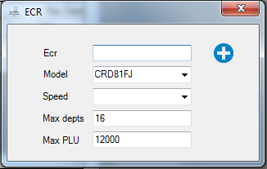

In order to edit a device’s parameters, select the corresponding device by clicking on it from the devices list and proceed to edit the parameters. To save the changes, please click on the edit button .

To delete a device, select it by double clicking on it from the devices list, click on the delete button.

PARAMETERS MENU
It is represented whit the following icon:

This module will allow you to read and configure the ECR parameters such as surcharge and discount rates, headings, foot notes, bar codes, among others.

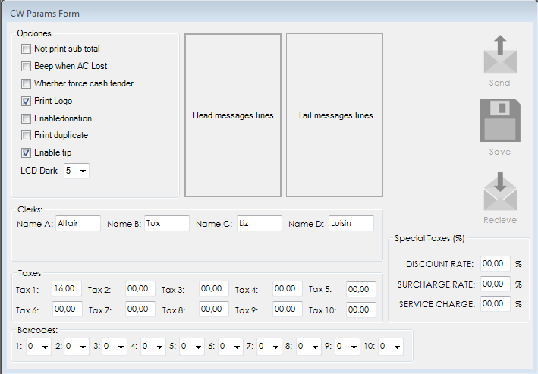

Reading the device′s parameters
To read the device configuration parameters, click on the Receive Button. Then a progress window will be shown during the data transfer. If you wish to abort the process, you may press the Stop task button.

 | 
Receive and Stop task icons.

Parameters Configuration
After you finished editing the ECR parameters list, press the Save Button to save the changes and then click on Send Button. A progress window will be displayed during the data transfer. If you wish to abort the process, you may press the Stop task button.
 |  | 
Save and Send icons.

DEPARTMENTS MENU
It is represented whit the following icon:
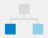
This module you will be able to read and configure the departments of your cash register. Before reading the departments you will require having read the parameters of your cash register, given that they include the associated rates.
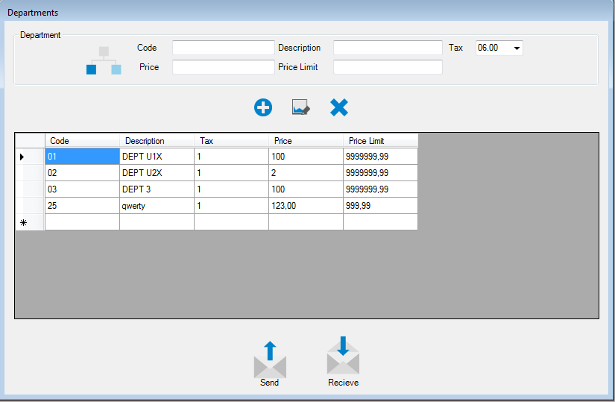

Reading the Department Parameters
In order to read the ECR departments, click on the Receive Button. Then a progress window will be displayed during the data transfer. If you wish to abort the process, you may press the Stop Task button.

Entering a new Department to the device
To enter a new department you should specify the following:
- Department Code: It’s a Numeric identifier with a maximum length of 13 digits.
- Department Description: Field with a maximum length of 16 characters.
- Tax: Here you should select one of the devices configured rate.
- Price Limit: Numeric field with a maximum length of 7 integer digits and 2 decimals that must be split by a dot.
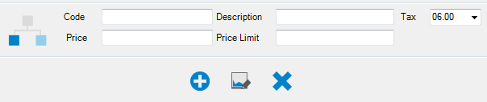

In order to create a new department, after you edited the code, description, tax and price fields click on the button.

Editing a department
In order to change a department values, double click on the department in the department list, edit the fields (code, description, rate and price) as required and then click on the button.

Deleting a department
In order to delete a department, double click on the item in the department list and then click on the button.
If you wish to delete more than one department at a time, select the list and click on the button, as show bellow.
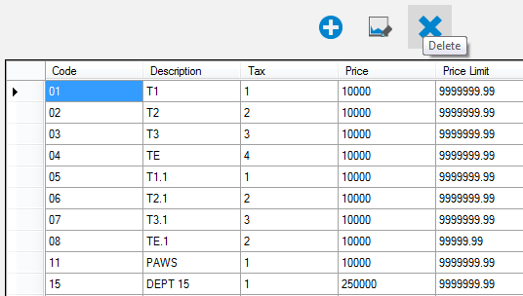

Sending departments
Press send and then a chart will be shown during the data transfer. If you wish to abort the process, you may press the Stop task button.

PLUs
It is represented whit the following icon:

This module you will be able to read and configure the PLUs in your cash register. Before reading the PLUs you shall read the Departments in your cash register, given that they are required to indicate the department that each PLU is associated to.

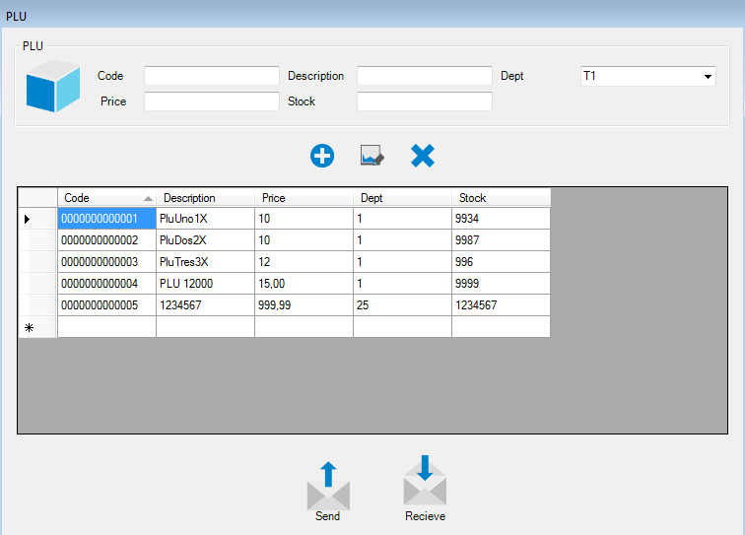

Configuring the PLU
Entry parameters:
- Code: Numeric field with a maximum length of 13 digits.
- Description: Alphanumeric field with a maximum length of 16 characters.
- Price: Numeric field with a maximum length of 7 integer digits and 2 decimals that must be split by a dot.
- Department: requires the selection of one of the Departments configured in the device, obtained from the previous reception of Departments.
- Stock: Numeric field with a maximum length of 6 digits.
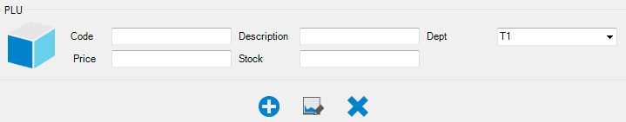

Creation of a new PLU

In order to create a new PLU, double click on the white line at the bottom of the PLUs list, edit the fields (code, description, price, department and stock) then press the button.

Editing a PLU

In order to edit a PLU, double click on the item on the PLU list, edit the fields (code, description, price, department and stock) as required and then press the button.

Deleting a PLU

In order to delete a PLU, double click on the item on the PLU list and then press the button.
If you wish to delete more than one PLU at a time, select the list and press the button, as show bellow.

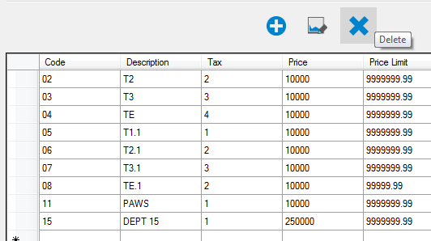

Sending PLU
Press send and then a chart will be shown during the data transfer. If you wish to abort the process, you may press the Stop Task button.

KEYBOARD
It is represented whit the following icon:
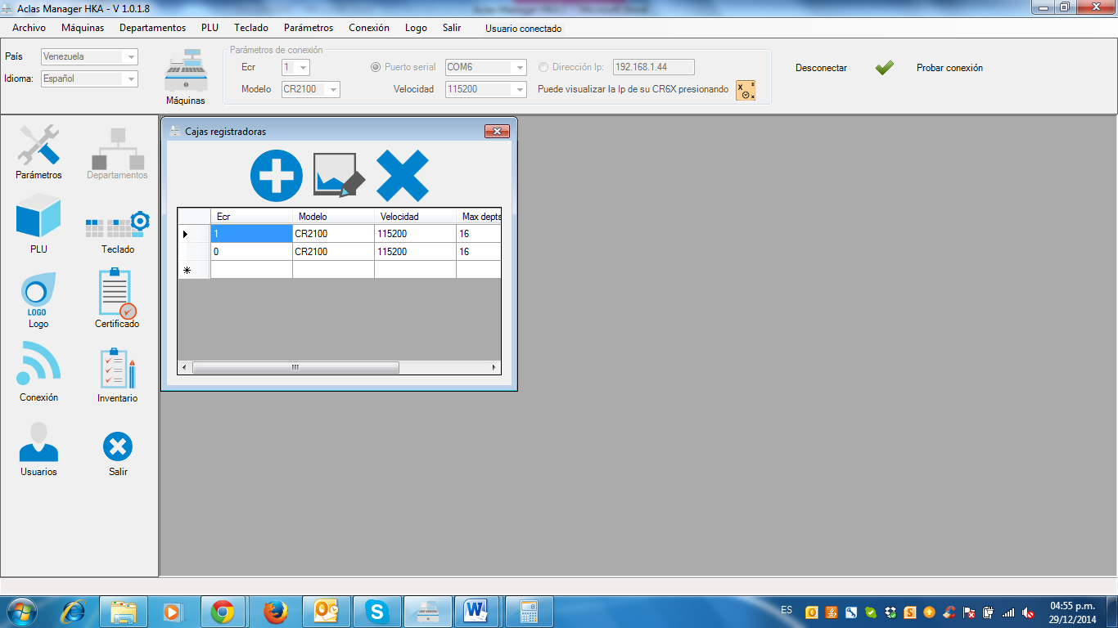
This module the application will show a module that displays a virtual keyboard in order to configure the short cut of your device.
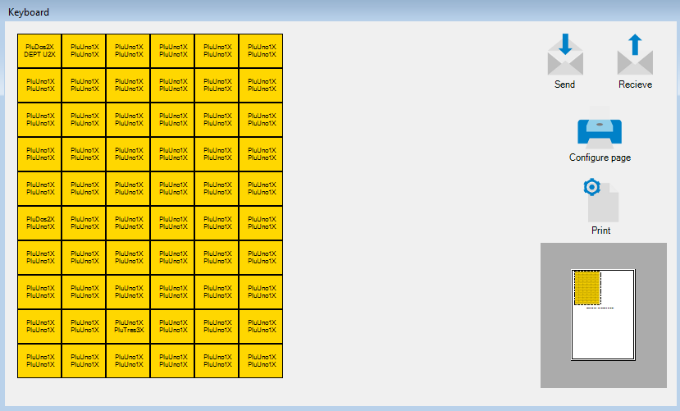
Once you have selected the desired key, indicate the kind of data that you wish to associate to it. You may link a Department or a PLU independently. According to the case the list of items in such category will be displayed. Once the selected item is satisfactory press save.
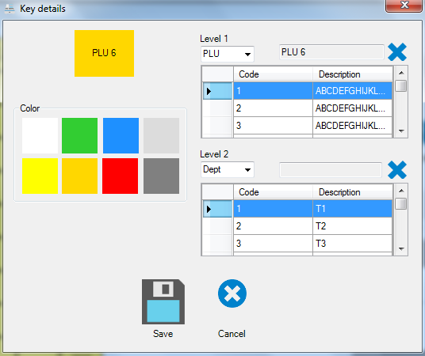

LOGO
It is represented whit the following icon:
This module will allow you to configure the logo that will be printed on your documents, locate file format bmp image by double clicking on Examine. Once you have selected the image and after finishing the resizing process (if required), press send to configure your cash register’s logo.

